**2.Install Kubernetes on Cloud**

Connect to AWS console and navigate to EKS service to create an EKS cluster

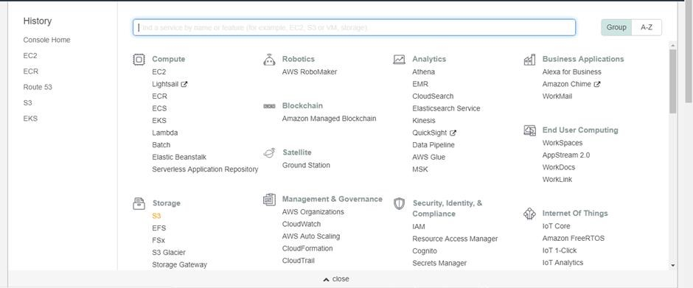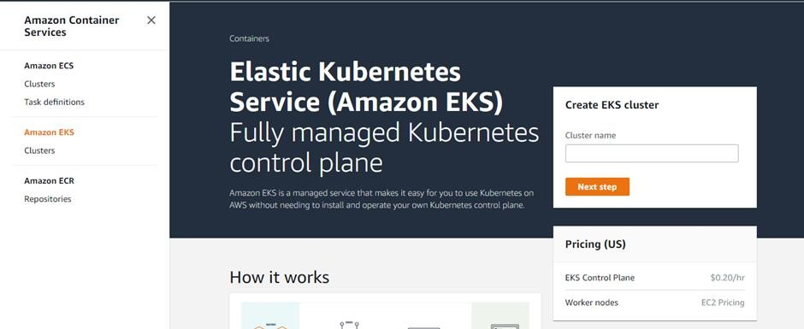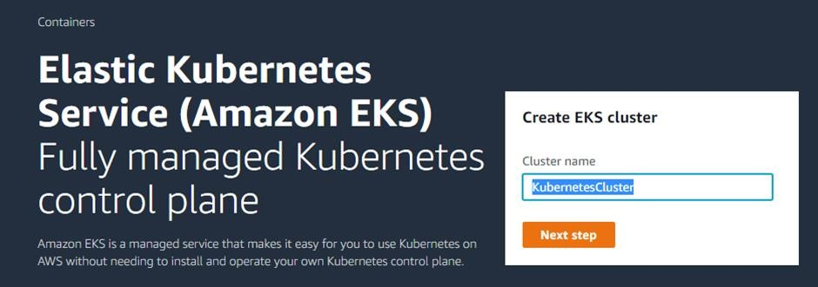

Configure **Role name** used by EKS rest.

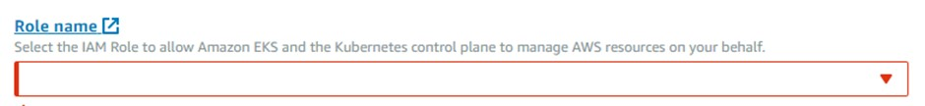

Click on **Create Role** and provide the policy details. Select **EKS** from the service list.

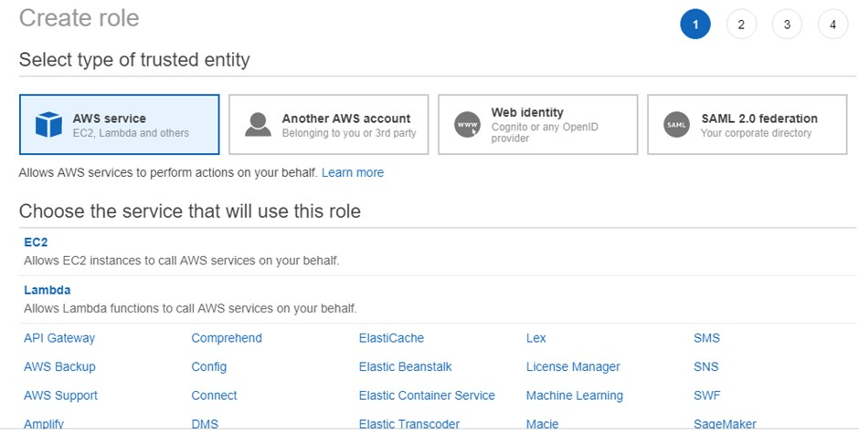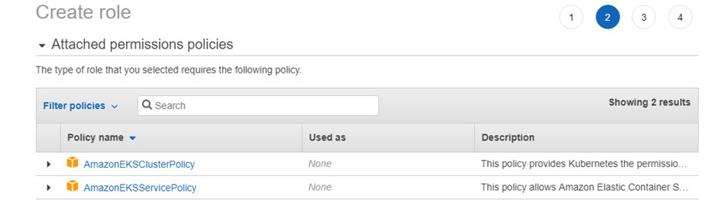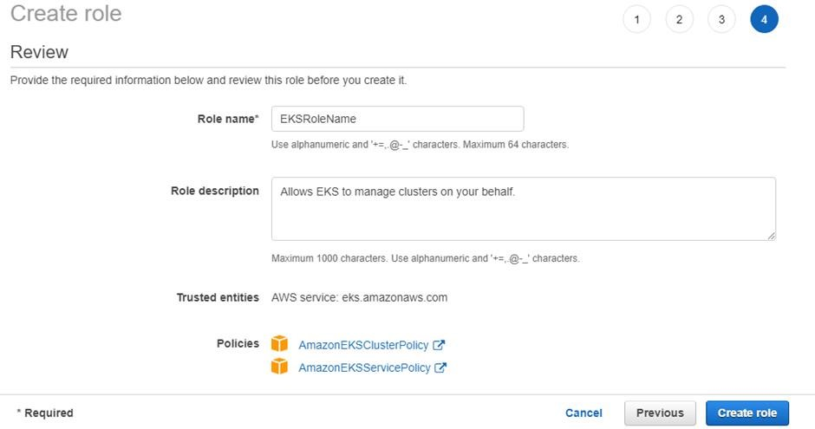

Select the newly created role name from the list while creating the EKS cluster

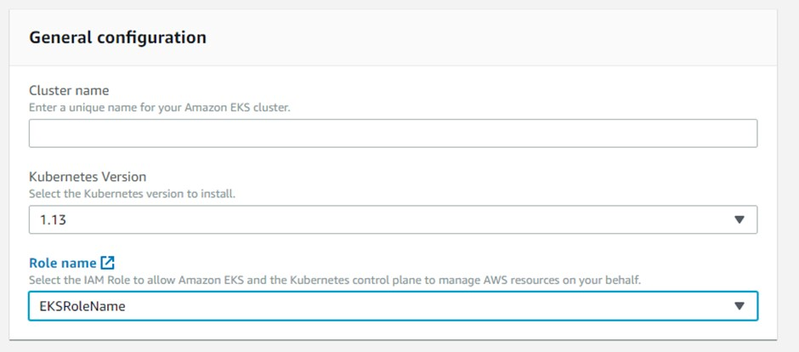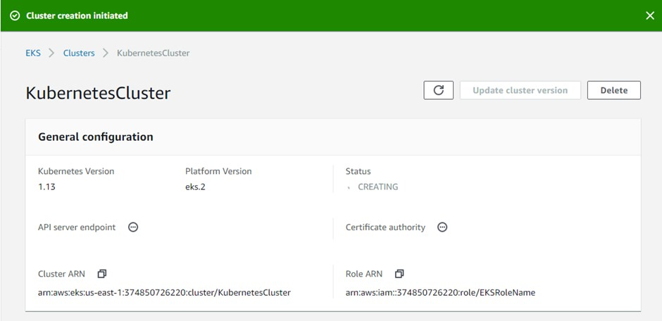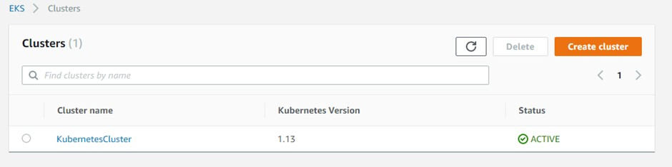

**wget** [**https://amazon-eks.s3-us-west-2.amazonaws.com/1.10.3/2018-07-**](https://amazon-eks.s3-us-west-2.amazonaws.com/1.10.3/2018-07-26/bin/linux/amd64/kubectl)

[**26/bin/linux/amd64/kubectl**](https://amazon-eks.s3-us-west-2.amazonaws.com/1.10.3/2018-07-26/bin/linux/amd64/kubectl) **chmod +x kubectl**

# ./kubectl

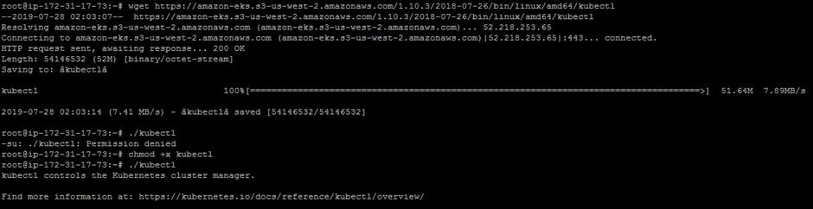

# mkdir bin cp ./kubectl $HOME/bin/kubectl && export PATH=$HOME/bin:$PATH kubectl version kubectl version --short --client

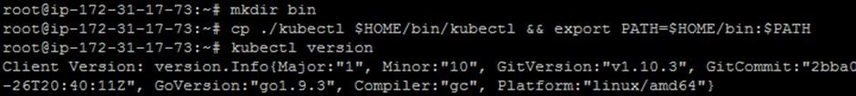

**wget** [**https://amazon-eks.s3-us-west-2.amazonaws.com/1.10.3/2018-07-**](https://amazon-eks.s3-us-west-2.amazonaws.com/1.10.3/2018-07-26/bin/linux/amd64/aws-iam-authenticator)

[**26/bin/linux/amd64/aws-iam-authenticator**](https://amazon-eks.s3-us-west-2.amazonaws.com/1.10.3/2018-07-26/bin/linux/amd64/aws-iam-authenticator) **chmod +x ./aws-iam-authenticator**

# cp ./aws-iam-authenticator $HOME/bin/aws-iam-authenticator && export PATH=$HOME/bin:$PATH aws-iam-authenticator help

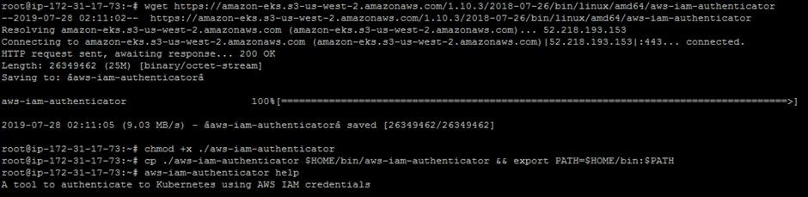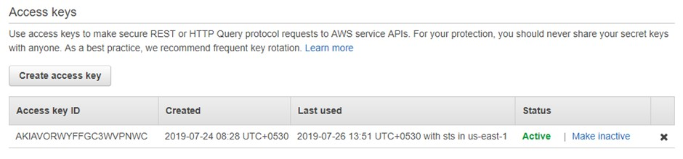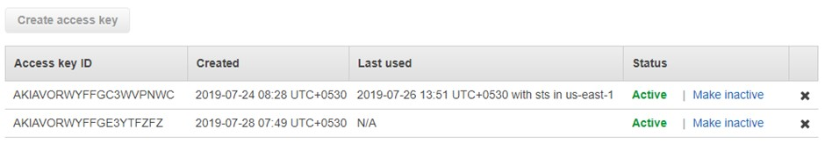

Configure AWS CLI and provide **Access Keys** and **Secret Access Keys** while configuring it.

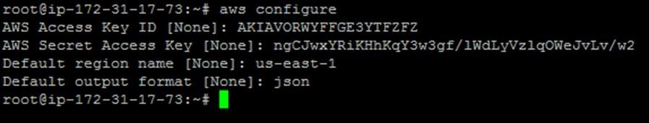

# awseks --region us-east-1 update-kubeconfig --name KubernetesCluster kubectl get svc

